Table of Contents

1 The User Portal 1
1.1 Log into the User Portal 1
2 Top Menu Bar 1
2.1 Apps 1
2.2 Profile Name (Extension) 1
2.2.1 Modify Profile Settings 1
3 The Home Page 4
3.1 Top Navigation 4
3.2 New Voicemail Messages 4
3.3 Recent Call History 4
3.4 Active Answering Rule 5
3.5 Active Phones 5
4 The Messages Page 5
4.1 Voicemail 6
4.2 Chat and SMS 6
4.3 Settings 6
4.3.1 Voicemail Greeting 7
4.3.2 Recorded Name 9
4.3.3 Email Notification 10
5 The Contacts Page 11
6 The Answering Rules Page 12
6.1 Allow/Block 13
6.1.1 Importing Contacts to Allow/Block Lists 14
6.2 Add an Answering Rule 14
7 The Time Frames Page 16
7.1 Add or Modify a Time Frame 16
7.1.1 Days of the Week 17
7.1.2 Specific Dates 17
7.1.3 Holidays and Observed Holidays 18
7.1.4 Custom Time Frames 19
8 The Phones Page 20
8.1 Add Phone 20

8.2 K7 One 21
9 The Music on Hold Page 21
10 The Call History Page 22
10.1 Filters 22
10.2 Blocked Numbers 22
11 The Contacts Dock 23
12 Applications 24
12.1 Attendant Console 24
12.2 WebPhone 24
12.3 K7 One 25

1 The User Portal
The User Portal is a web-based interface that allows you to access your company's unified communications solution (company contacts, phone numbers, messaging, and more).

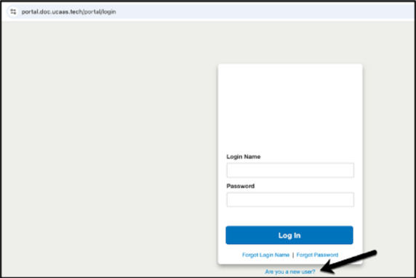
1.1 Log into the User Portal
- Navigate to the Portal URL provided by your Office Manager.
- Do you have a password?
Yes! Log in using your provided “Login Name” and “Password”.
No. Click on the “Are you a new user?” button. Provide your email and extension, and we'll email you your credentials.

2 Top Menu Bar
The top menu bar is a static tool. These dropdown menus ("Apps" and your profile name) follow you to every page in the User Portal.

2.1 Apps
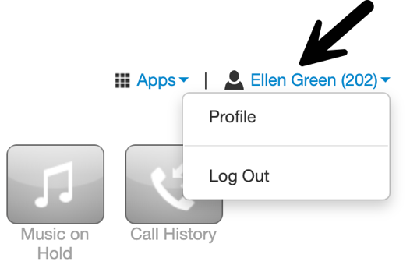
Click on the dropdown arrow next to “Apps” to open a list of your company's applications. Your list of applications will differ depending on your company's customizations. Examples of applications include the Attendant Console, WebPhone, and K7 One. Applications will open in a new browser tab.

2.2 Profile Name (Extension)
Your profile name (followed by your extension) is located on the far right-hand side of the top menu bar. Click on your profile name to access the profile menu. There are two options inside of the profile menu: “Profile” and “Log Out”.

2.2.1 Modify Profile Settings
You can use the “Profile” button to update your account details.

- Click on your name and extension number.
- Two options should appear: “Profile” and “Log Out”.
- Click “Profile” to reveal the Profile modal, as shown on the following page.
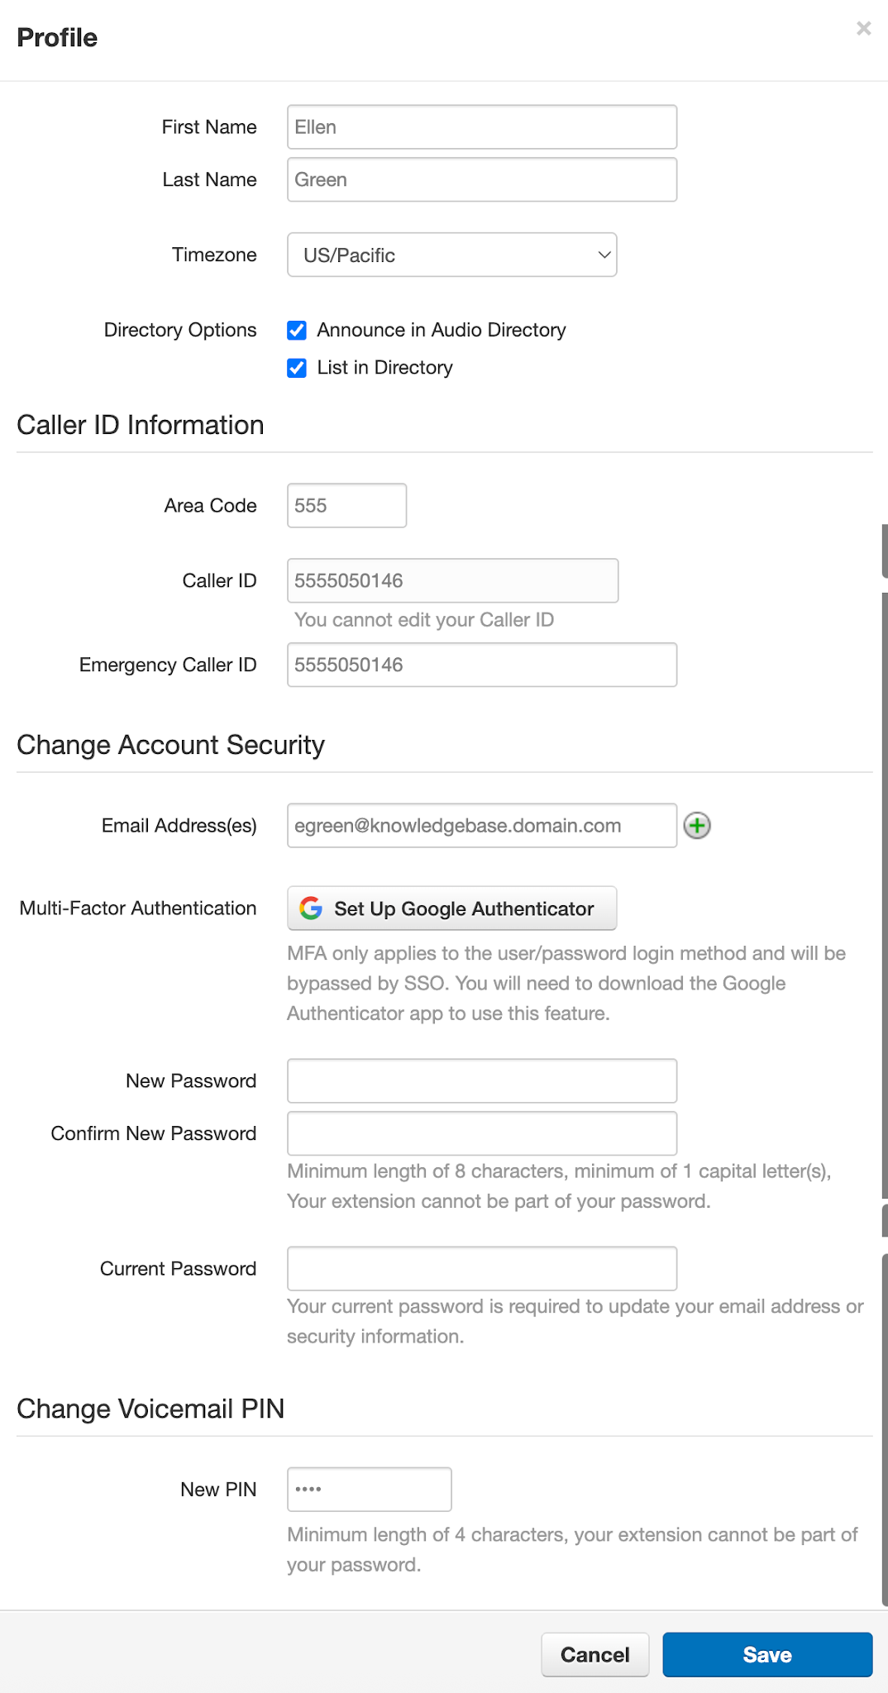

Field Name | Description
First Name | Used to define the first name within your directory listing and within your default voicemail greeting.
Last Name | Used to define the last name within your directory listing and within your default voicemail greeting.
Time Zone | Accuracy here is very important for seamless inbound call routing.
Announce in Audio Directory | Include yourself in the company's audio directory, allowing callers to be routed to your extension.
List in Directory | The system shows your name wherever company contacts exist (such as the Portal, WebPhone, and K7 One).
Area Code | Modify the area code associated with your Caller ID for outbound calls.
Caller ID | When making calls outside of your organization, this number is visible to the recipient of your call.
Emergency Caller ID | 911 Caller ID is not editable here; for changes, contact your Office Manager.
Email Address(es) | Enter the email where you receive notifications. To add additional email addresses, click the green plus sign.
Multi-Factor Authentication | Multi-Factor Authentication secures logins by requiring users to enter more than just their username and password. It adds an extra step in case a user's credentials have been compromised.  Note: For MFA-enabled users, logging in requires authentication via email or the Google Authenticator app.
New Password | Enter it here. Then, re-enter it in the “Confirm Password” field directly below to verify.
Confirm Password | Re-enter your new password in this field.
Current Password | Enter your existing password here to modify or change “Account Security” options.
Change PIN | Set a new numeric password for checking your voicemail messages by phone.

The following table explains the available fields within the Profile modal.


3 The Home Page
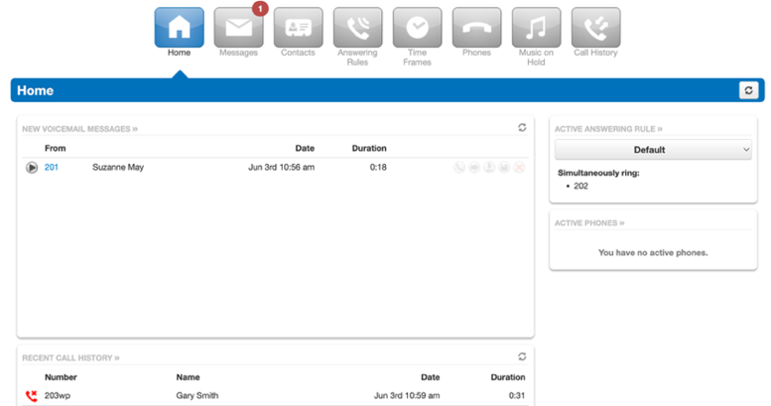
The User Portal's Home page provides quick access to your voicemail messages, recent call history, your active Answering Rule, and a summary of your active phones.

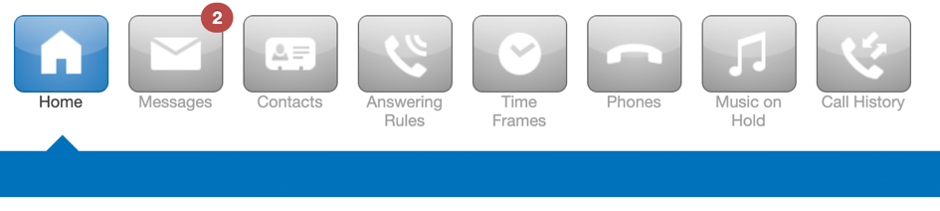
3.1 Top Navigation
The top navigation panel is below the “Profile” and “Log Out” options on the home page.

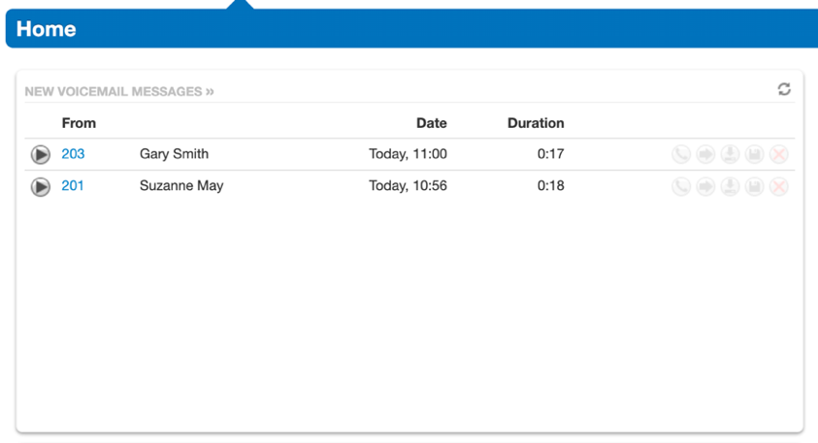
3.2 New Voicemail Messages
The New Voicemail Messages panel lists all new voicemails. For each message, the caller's number and caller ID name, along with the date, time, and duration of the voicemail are displayed. There are also several voicemail options: call to play, forward, download to your computer, save, or delete the message. These buttons are described in further detail in section 4.
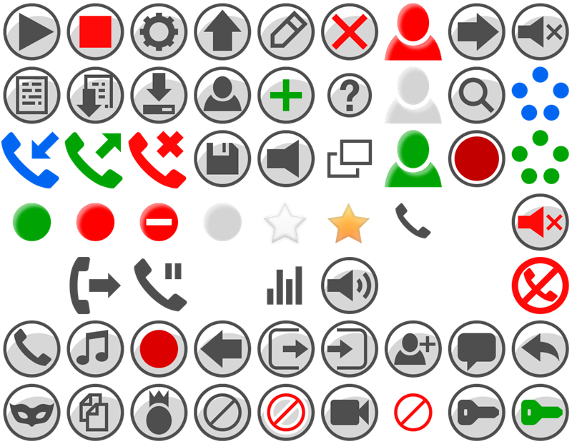 | Answered inbound call
 | Outbound call
 | Unanswered inbound call
 | Call was placed to a Conference Bridge

3.3

Recent Call History
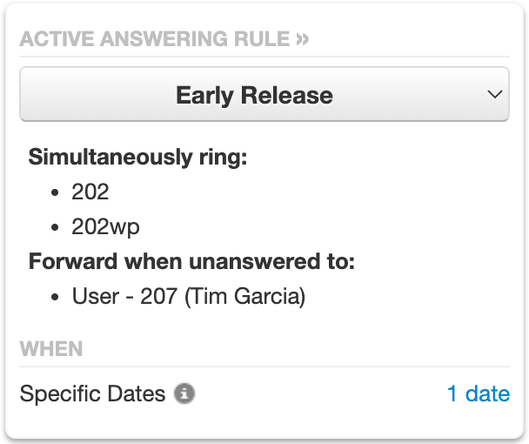
The Recent Call History panel displays an overview of your most recent calls.

3.4 Active Answering Rule
The Active Answering Rule panel displays which rule is currently in effect and how your calls are routed.
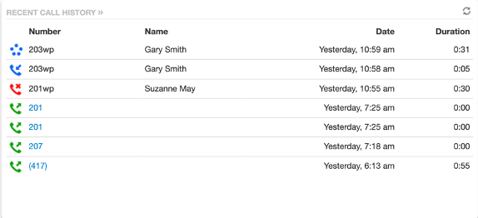
- To choose a different Answering Rule, use the dropdown tool and select one of the available options.
- Only the Answering Rules that match the current time frame will be listed as active. Example: An "Early Release" Answering Rule might have a Monday-Friday, 1:30 PM-5:00 PM time frame. This rule only appears as "active" when it's within that specified time frame (like Tuesday at 2:00 PM).

3.5 Active Phones
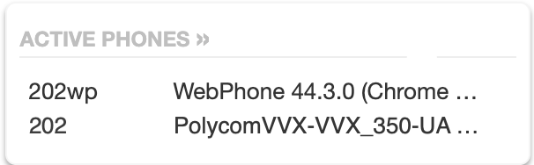
The Active Phones panel lists all devices registered to your account for making and receiving calls. If a device is missing, it is either not configured for your account, or it is unregistered. Make sure your phone is connected or your WebPhone is open. If problems persist, contact your Office Manager for assistance.


4 The Messages Page
Voicemail messages, chats, and message settings are displayed on the Messages page.

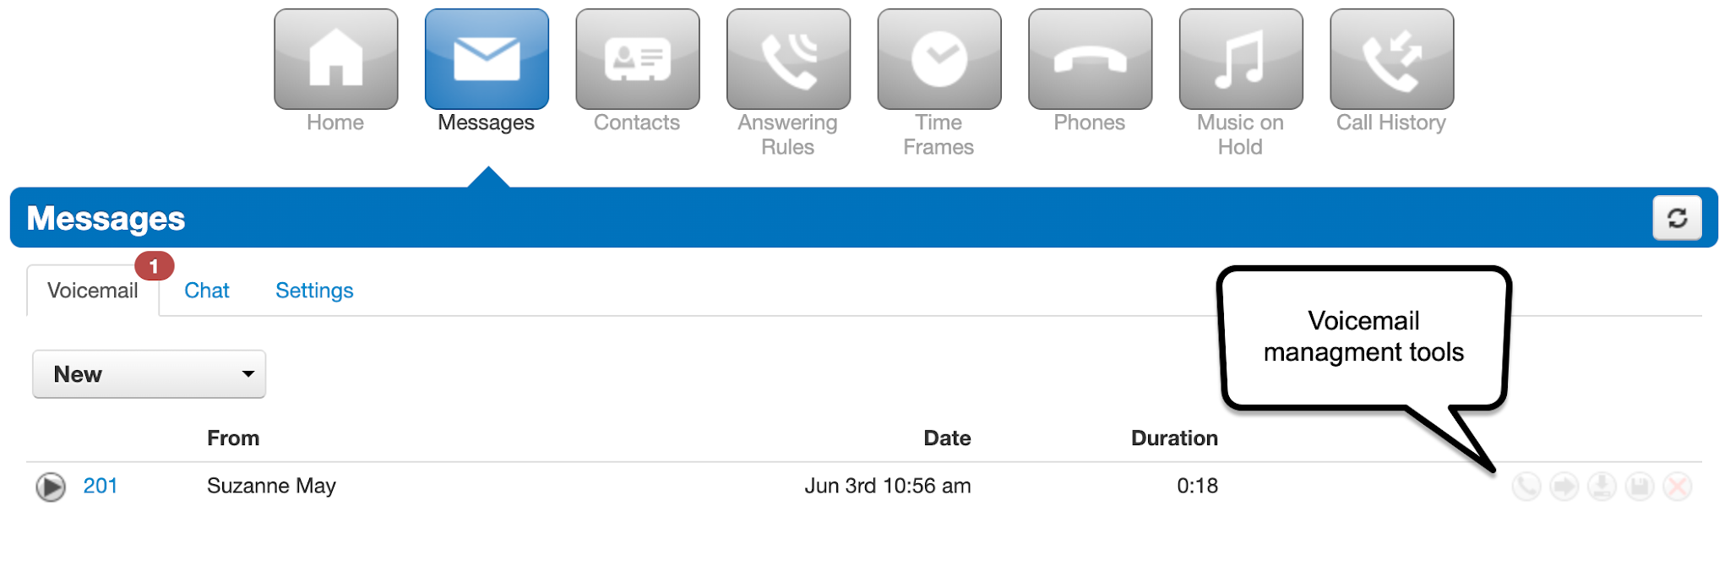

Voicemail management tools are available on the right-hand side of the page. They are as follows:

 | Download the voicemail to your computer.
 | Save a voicemail to your account's Saved folder.
 | Send the voicemail to your account’s Trash section. All trash is deleted daily.
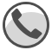 | Call your extension to play the voicemail.
 | Forward the voicemail to another extension.

4.1 Voicemail
Clicking the “Messages” button opens the Voicemail tab. At the top of this tab, there is a new message indicator that shows how many new voicemails are in your account. Use the dropdown tool to filter voicemails by new, saved, or trash. Each entry displays the caller's phone number, caller ID name, date, time, and the duration of the message.

4.2 Chat and SMS
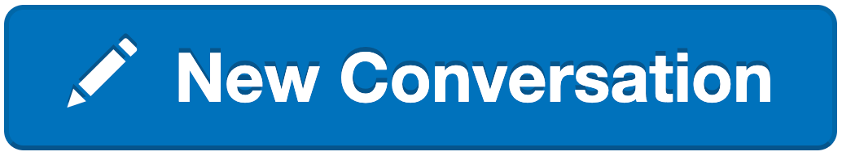 | Start a new conversation.
 | Reply to a message.
 | Delete a message.
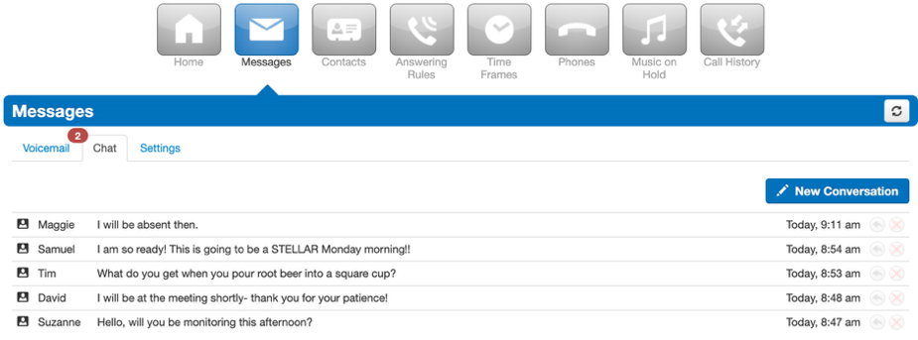
“Chat” and “SMS” conversations are stored on the Chat tab inside of the Messages page. The message is displayed with the contact’s name, the last message sent/received, and the time and date of the last message sent/received.

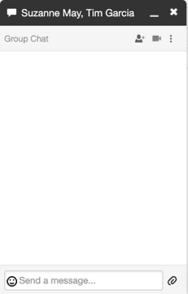
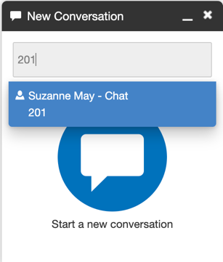
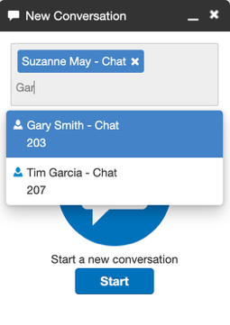
As seen in the first image, the “New Conversation” button opens the New Conversation dock. From there, search for or enter a contact's name or extension to start a chat.

The second image shows how to search and select multiple contacts. After selecting users, click the “Start” button to open the Chat/SMS dock, depicted in the third image.

4.3 Settings
Voicemail settings, greetings, notifications, and directory contact entries are managed in the Settings tab.
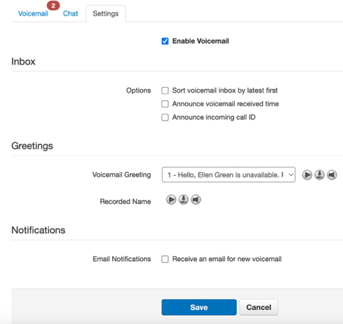

Field Name | Description
Enable Voicemail | Allows callers to leave voicemails for your user.
Sort voicemail inbox by latest first | Your most recent voicemail is listed first.
Announce voicemail received time | Your voicemail announces the time a message was received.
Announce incoming call ID | Your voicemail reads the Caller ID number for incoming calls.
Voicemail Greeting | This field contains your voicemail greeting used in the company directory. It also provides the options to play, download, and manage your voicemail greeting (see section 4.3.1).
Recorded Name | Play, download, and manage your recorded name for the company directory (see section 4.3.2).
Receive an email for new voicemail | Check this box to reveal email notification format options (see section 4.3.3).

4.3.1 Voicemail Greeting
Play your voicemail greeting.
Download your voicemail greeting to your computer.
Open the Manage Greetings modal.
Use the tools to the right of “Voicemail Greeting” to play the current greeting, download it, or manage it.
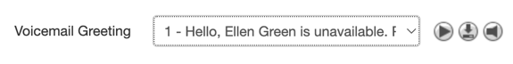

Clicking the “manage” button opens the Manage Greetings modal. Beyond playing and downloading voicemail greetings, this modal provides additional options to edit, delete, and add new voicemail greetings.
 | Change your voicemail greeting.
 | Permanently remove the voicemail greeting from the phone system.
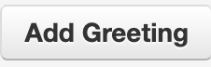 | Use the TTS (Text to Speech), Upload, or Record options to add a new voicemail greeting. You can store multiple voicemail greetings in the phone system.
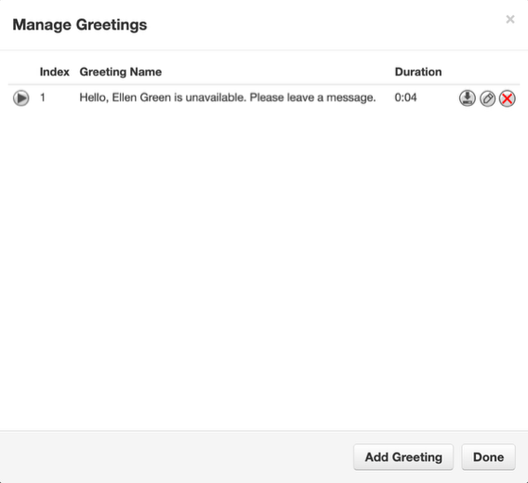

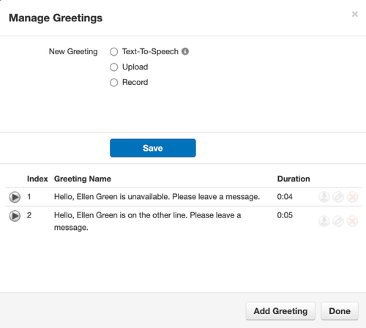

4.3.1.1 New Greeting
Clicking the “Add Greeting” button will display the new greeting section of the Manage Greetings modal (shown to the right).

Text to Speech: This is the first available method for creating a new greeting. This method allows you to create an audio greeting using a given text to speech engine. Be sure to click save once your entries are complete.

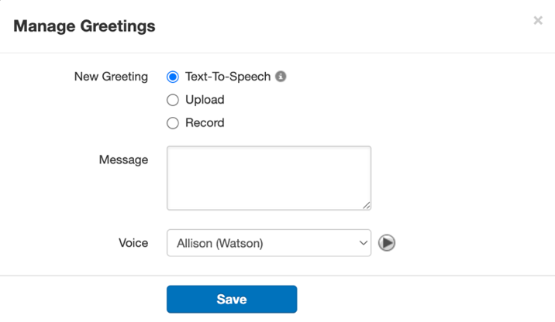
- Type a greeting that will be generated into speech here.
Note: Use punctuation and capitalization to create natural pauses, inflections, and emphasis.
- Choose from a range of available voices to deliver the message.

Upload: Upload an MP3 or WAV file to use as your new voicemail greeting. Be sure to click upload after your entries are complete.

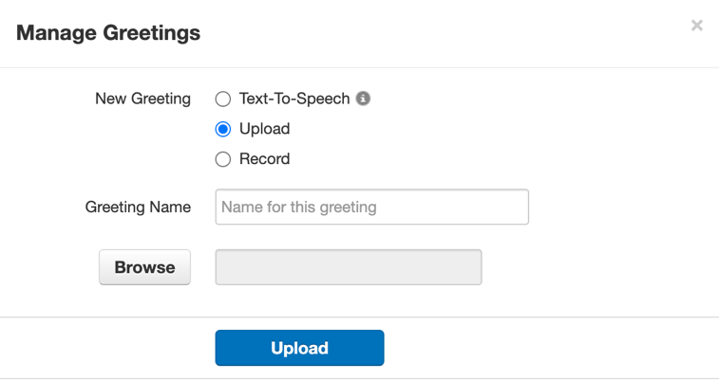
- Select a Greeting Name that will be used for your reference.
- Browse for an MP3 or WAV file on your computer. The selected file appears here.
- Be sure to upload after your entries are complete.

Record: Record your voicemail greeting using the phone at the extension you select.

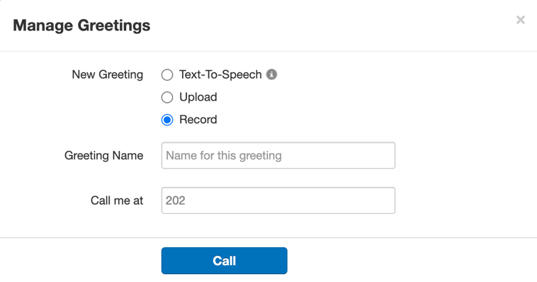
- Create a Greeting Name to be used as reference.
- Enter a Call me at number where you can be reached to record your voicemail greeting.
Note: Enter the specific device you want to ring. This may be your main extension (1001) or your extension with a specific device suffix (e.g., 1001wp, 1001m, 1001a, 1001b)
- Click “Call”. Answer the device and record your greeting.

4.3.2 Recorded Name

Play your recorded name.
Download your recorded name.
Open the Manage Recorded Name modal.
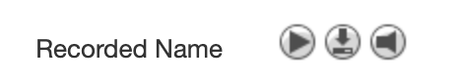

The table on the right displays the buttons next to the “Recorded Name” setting.

Within the Manage Recorded Name modal, use the TTS (Text to Speech), Upload, or Record options to add a new recorded name to the phone system.
Note: The phone system stores only one recorded name at a time.
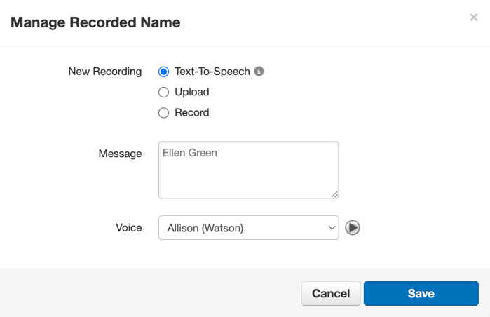
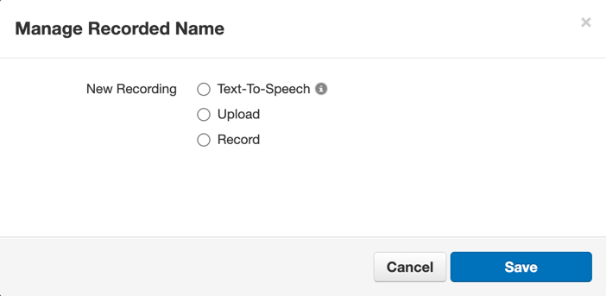

Text to Speech: Create a recorded name using a TTS engine. Be sure to click save once your entries are complete.

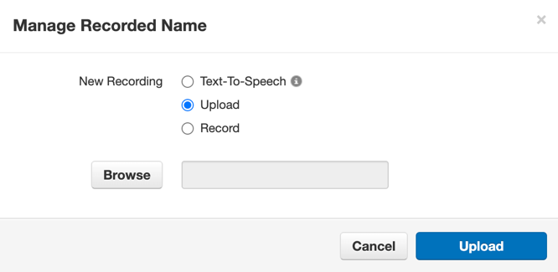
Upload: This method provides another way to create a new recorded name.

- Browse to select an MP3 or WAV file on your computer.
- Upload to use it as your new recorded name.

Record: Record a new recorded name using the phone at the extension you select.
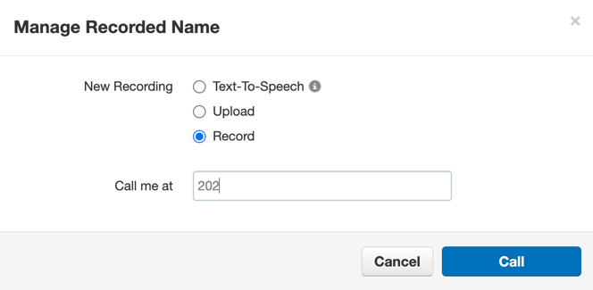
- Enter the number you want to be called at to record your voicemail greeting.
Note: Enter the specific device you want to ring. This may be your main extension (1001) or your extension with a specific device suffix (e.g., 1001wp, 1001m, 1001a, 1001b)
- Click “Call”. Answer the device and record your name.
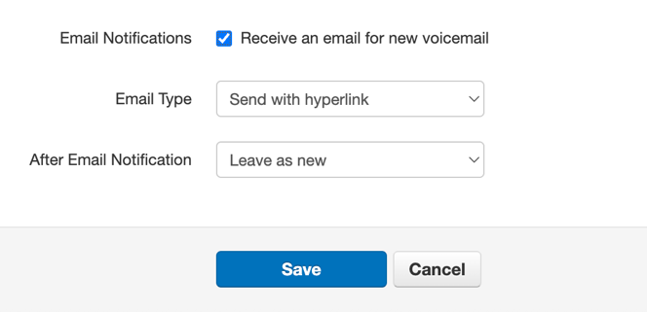

4.3.3 Email Notification
You can select the format for your email notifications from several Email Notification options. After you check the “Receive an email for new voicemail” box, the following options are displayed (see the image on the right and the corresponding table below):

This table outlines the "Email Type" and "After Email Notification" options for voicemail notifications.

Field Name | Description
Email Type | Select how the voicemail recording appears in your email notification.  - Send with hyperlink  - Send with brief hyperlink  - Send with attachment  - Send with brief attachment
After Email Notification | Select what happens to a voicemail after its notification is sent via email.  - Leave as new  - Move to saved  - Move to trash


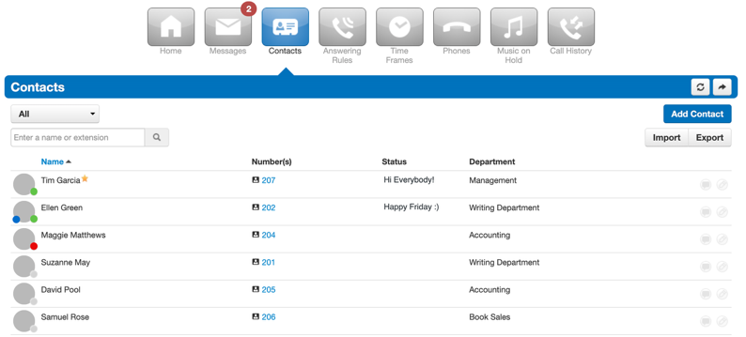

5.The Contacts Page
The Contacts page displays users who have "List in Directory" enabled in their profile. If a user is missing from the list, their "List in Directory" setting is disabled.

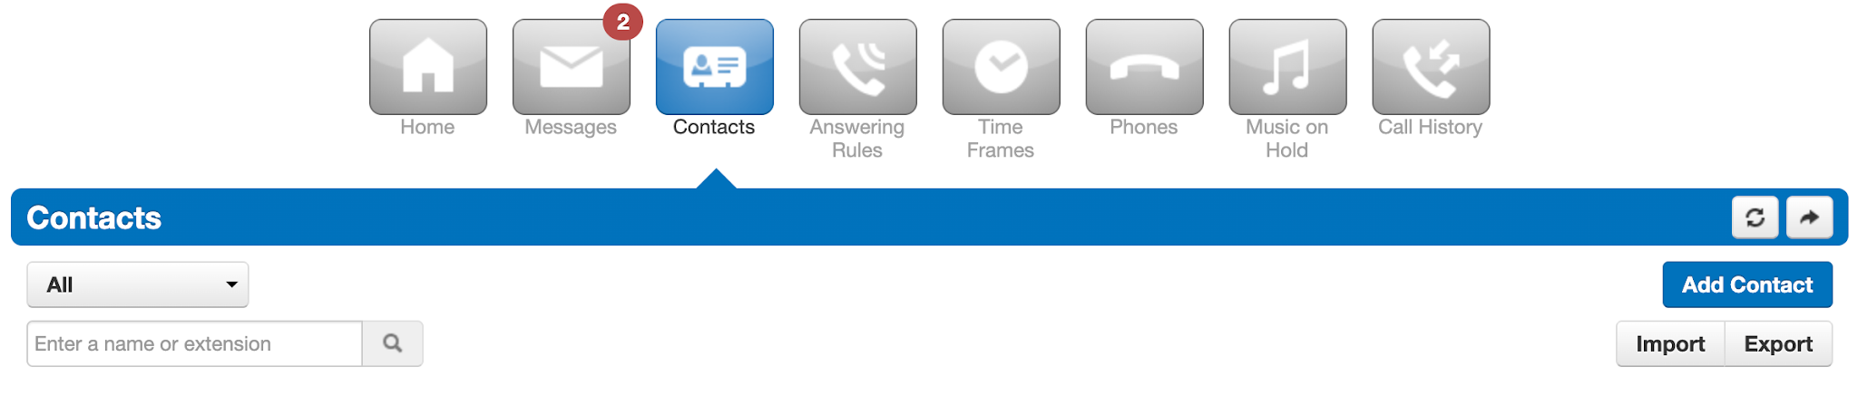 | Filter by “Contact Groups” or “Status”
 | Contact Groups:  - All  - Favorites  - Shared  - My Contacts  - Coworkers  - Sites  - Departments | Status:  - Available  - Busy  - Offline
 | Open the New Contact modal and enter the new contact’s information.
 | Search for a contact using either their name or directory extension.
Note: We recommend first exporting contacts in your preferred format and then using the resulting file as a template.

The final file can be imported as a .csv, .CSV, or .vcf. Note: The “Primary Phone” column will be imported as the “Work number” field instead of the “Extension” field. Basic Users can only import contacts but cannot import other users.
Create a CSV file for your desired contact group. After clicking “Export,” choose a group from the “Contacts to export” dropdown field:

- All
- Favorites
- Shared
- My Contacts
- Coworkers
- Sites
- Departments

Then, choose an “Export format” from the next dropdown field.

- Outlook (CSV)
- Google (CSV)
- Apple (vCard CSV file)
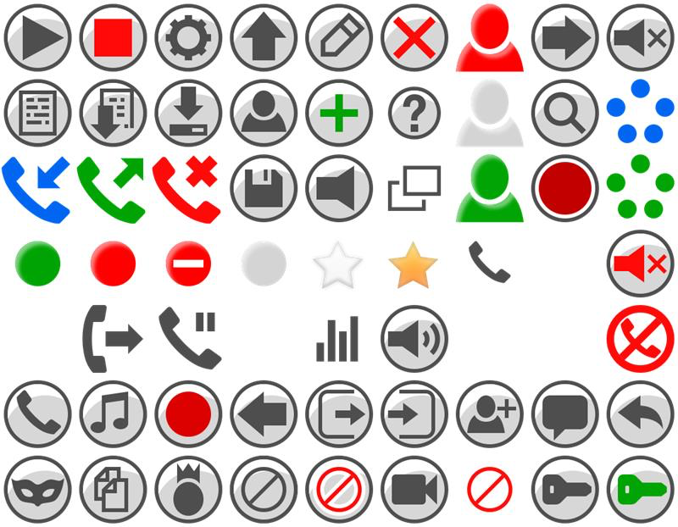 | Open the Edit Contact modal. Here, you can configure the contact with a different:  - First Name  - Last Name  - You cannot change the extension number  - Work Number  - Mobile Number  - Home Number  - Fax number
 | Open a Chat/SMS dock with that user as the recipient.
 | Refresh the page and pull any new data that has been added.
 | Open a compact window with your contacts and options to initiate video or phone calls.
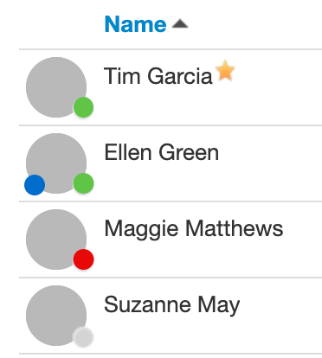 | The icons next to each contact indicate their current availability:  - Green circle: The contact is available for calls.  - Blue circle: The contact is available for chat.  - Red circle: The contact is busy.  - Gray circle: The contact is offline.  - Star: The contact is in your “favorites” group.
 | You can add a contact to your “favorites” group by hovering over the right side of their name until a gray star appears. Click this star to turn it gold, adding them to your “favorites” group.


6 The Answering Rules Page

Answering Rules work in conjunction with time frames. Together, they allow you to decide how you treat incoming calls.

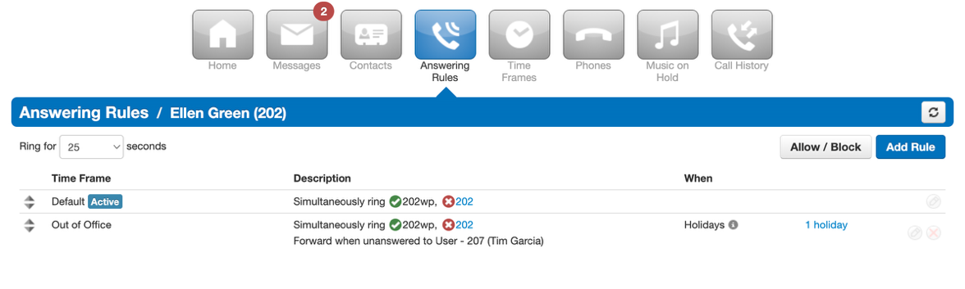
Are you on vacation? Is it the weekend? Are you working a normal shift? Simply create a time frame and then assign it to an Answering Rule. When the time frame is in effect, then the associated Answering Rule routes calls as configured.

Clicking the “Answering Rules” button takes you to your Answering Rules page, where all your configured rules are listed. Each rule displays its name, a description of how it routes calls, and options to edit or delete it. Every account comes with a Default rule that you cannot delete.

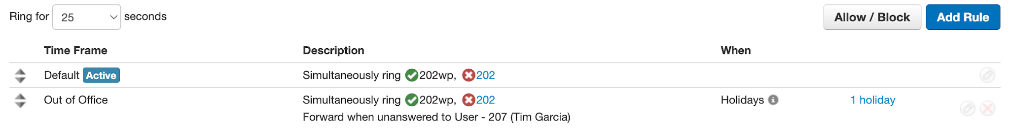 | Use the dropdown menu to set the desired ring time for incoming calls. After this duration, the call will be sent to voicemail or the destination specified in the “When unanswered” field of your active Answering Rule.
 | Use the arrows to move a rule up/down. The top rule gets priority and is active if its time frame is “now”.
 | The phone is registered on the system.
 | The phone is unregistered.
 | Opens the Allow/Block modal, where you can manage your allowed and blocked numbers (see section 6.1).
 | Opens the Add an Answering Rule modal (see section 6.2).
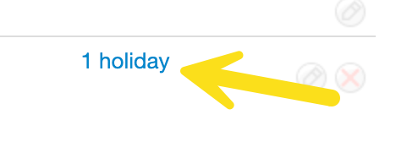 | Click this link to see a summary of the time frame.
 | Opens the Edit Answering Rule modal. This modal mirrors the Add Answering Rule modal (see section 6.2) and allows you to update an existing rule’s settings. Remember to save your changes.
 | Deletes the Answering Rule. The default rule cannot be deleted.
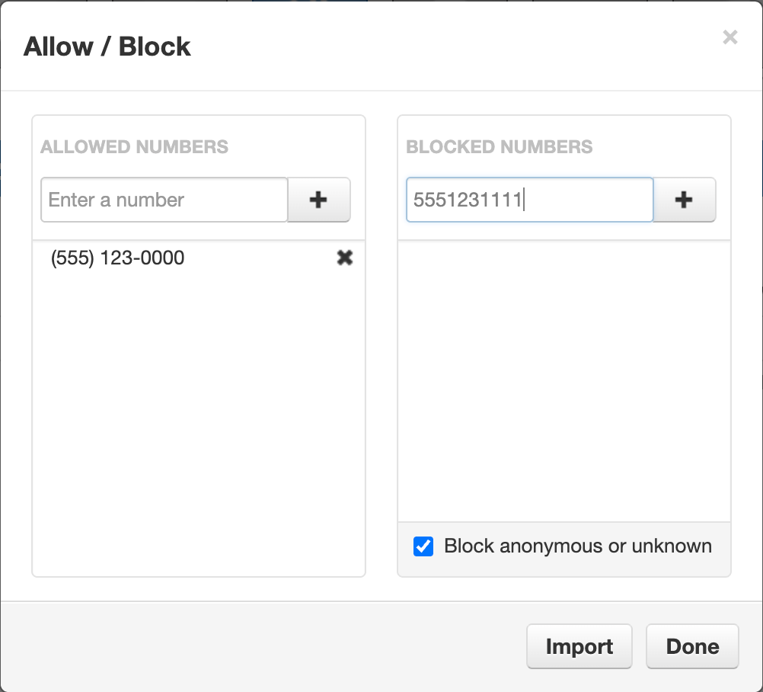 | Adding a number here bypasses Call Screening and “DND” (do not disturb), directing calls straight to you without requiring the caller to record their name.  Note: The phone number must be entered without dashes or parentheses.
This list allows you to add phone numbers you don't want to receive calls from.

Note: The phone number must be entered without dashes or parentheses. This feature will not block SMS messages.
 | Block callers that don’t pass along a “calling name”.
 | Allows CSV import of contacts (see section 6.1.1).

6.1 Allow/Block
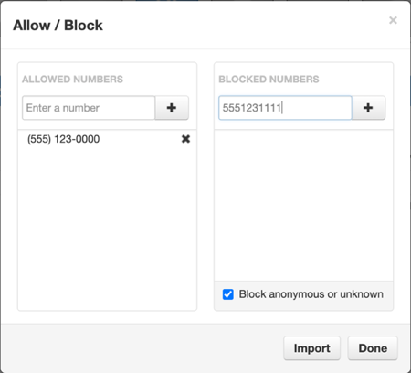
You can allow or block calls within the Allow/Block modal.

6.1.1 Importing Contacts to Allow/Block Lists
You can efficiently manage your Allow/Block lists by importing contacts via a CSV file. Clicking “Import” in the Allow/Block modal opens the file dialog shown to the right.
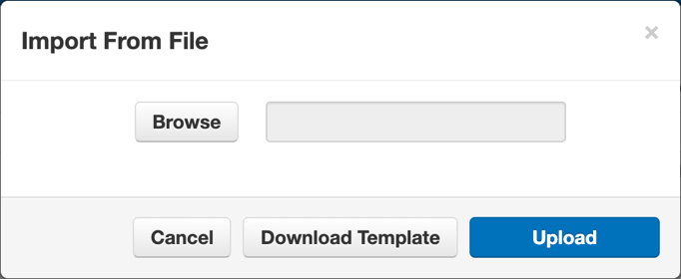
- Click “Download Template”. Input your contact information on this CSV template.
- Save the CSV file to your computer.
- Click “Browse” and locate the CSV file on your computer.
- Select the file and upload it to add the contacts from the CSV file to their corresponding lists.

6.2 Add an Answering Rule
Clicking the “Add Rule” button opens the Add an Answering Rule modal shown on the right. The table below describes the fields in that modal.
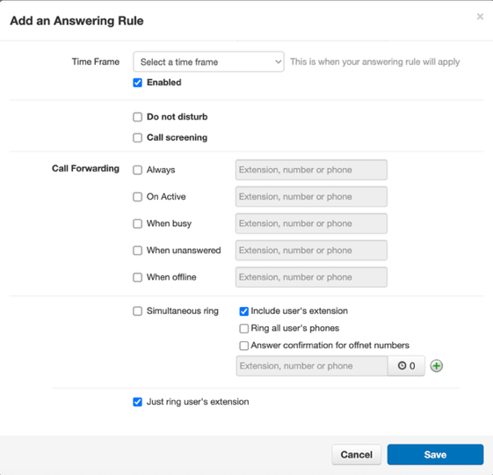

Field | Description
Time Frame | 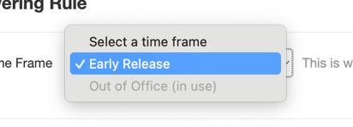  Use the dropdown arrow and select a time frame when your Answering Rule will apply.
Enable | Enable the Answering Rule.
Do not disturb | Stop calls from ringing your devices. Calls will go to voicemail if it's set up or disconnect otherwise.
Call screening | When Call Screening is enabled, callers record their name before your devices ring. If you answer, you'll hear their name and can press 1 to connect or simply hang up to send them to voicemail or your configured unanswered call destination.  Note: Call Screening can be used in conjunction with simultaneous ringing, just ringing the user's extension, or Call Forwarding.
Call Forwarding
The Call Forwarding options route calls based on your selections. You can forward calls to another user or any external phone number, even if it's not part of your account or system. If you select a specific "phone," only that device rings. You can also route calls to a voicemail box, a conference call, or other destinations.
Always | When active, this rule automatically forwards all incoming calls to your chosen destination.
On Active | If a user is on a call on one or more devices, then new incoming calls are forwarded to the specified destination. This would be used in instances where users want to turn off call waiting.
When Busy | Direct calls when your line is full. Incoming calls will go straight to your voicemail, with no other destinations available. This option is only available if you've chosen, "just ring user's extension," not "simultaneous ring."
When Unanswered | If the user's no-answer timeout expires ("ring for X seconds" on the Answering Rules table), then the caller will be sent to the specified destination.
When Offline | If the user is "offline", then the caller is forwarded to the specified destination.  Note: This only works with users who have devices. This is not intended to be used on system users like Auto Attendants and queues.
Simultaneous ring
The "Simultaneous ring" setting lets you choose which devices ring for incoming calls. By enabling it, you can ring other extensions or phone numbers along with your own.
Note: The concept of “Simultaneous ring” applies to devices only (extensions, phones, and numbers) and not as a catch-all for other users.
Include user’s extension | The user's extension is their main device only. This does not include alphanumeric devices (such as their WebPhone).
Ring all user’s phones | This rings all devices that are registered for that user, including alphanumeric devices (such as their WebPhone). If checked, it will also include any devices added to that user in the future.
Answer confirmation for offnet numbers | Receive audio confirmation when the call is answered by an off-net number ("press 1 to accept this call"). Use this option if you do not want work voicemails on an off-net number.
Extension, number, or phone | Add in specific devices, other extensions, or phone numbers that should also ring. Click on the “+” button to add a new destination. Each new destination here has an optional ring delay that can be configured between 0 and 10 seconds.
Just ring user’s extension | This option is available only when Simultaneous Ring is disabled. Enabling "Just ring user's extension" means only your default device will ring.


7 The Time Frames Page

Time frames configure specific hours of certain days or a span of days when features such as Answering Rules or Auto Attendants will be active. It is best practice to create multiple time frames before moving on to create Answering Rules (e.g. during this time frame, forward calls to my cell phone). To view and create your available time frames, click on the “Time Frames” button in the top navigation menu bar. Here you see all the time frames available to you.

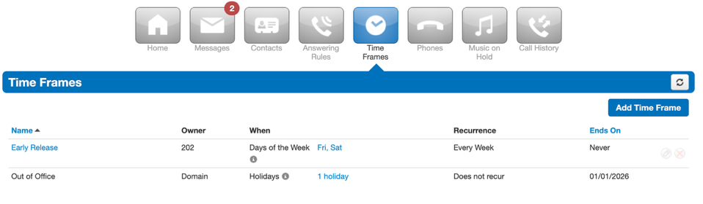
- Blue text time frames are yours to edit or remove.
- Time frames in black text are system-defined and visible to everyone in your organization. You can't edit or delete them.
- For changes to system-defined time frames, please contact your Office Manager.

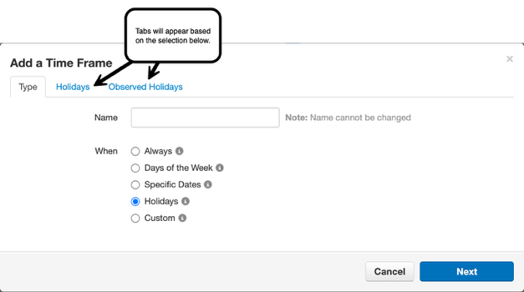
7.1 Add or Modify a Time Frame
To add a time frame, click on the “Add Time Frame” button. This opens the Add a Time Frame modal. The first tab, “Type”, is where you decide what type of time frame you want to add. Will it always be applied? Will it only be applied on specific days of the week? The choice is yours.

Field Name | Description
Name | The name of your time frame is entered here.  Note: Names cannot be changed.
When | This section defines when the time frame is active. All time frame types, except "Always", offer an optional recurrence setting.  - Always: This is always / all the time.  - Days of the Week: Define your time frame using a day of the week. For example, you can select the first Monday of the month (see section 7.1.1).  - Specific Dates: Define your time frame using exact dates and times, with the option to create multiple specific dates. For example, you can select December 23rd at 5:00pm – January 4th at 8:00am (see section 7.1.2).  - Holidays: Select from a list of local and international holidays with an optional choice to recur; holiday options are maintained and updated by Calendarific (see section 7.1.3).  - Custom: This selection can combine “Days of the Week,” “Specific Dates,” and “Holidays” all together to suit any time frame need (see section 7.1.4).

7.1.1 Days of the Week
Name your new time frame and select the “Days of the Week” option. Then click “Next”. This opens the Days of the Week tab shown below on the left and enables you to manage start/end times for those days as shown on the right.
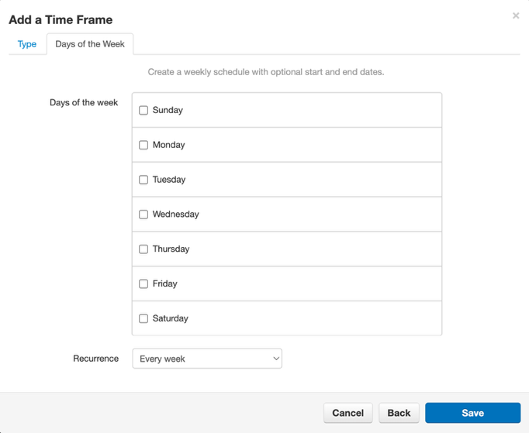

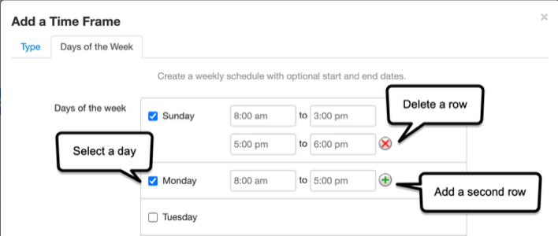

- First select the day of the week. This allows you to see the start time (the first entry field) and the end time (the second entry field).
- Times appear by default as 8:00am – 5:00pm. If desired, determine start and end times for specific days of the week.
- Should all days have the same time? Hover over a row and the “Copy to all” button appears. Use this to copy times from one day to all days selected.
- Optionally, use the green “+” button to add a second row. This row can be used to add an additional time range for a specific day. For example, perhaps the time frame on Sundays should be defined as 8AM through 3PM, but also from 5PM through 6PM. Use the red “X” button to delete the second row if you change your mind.
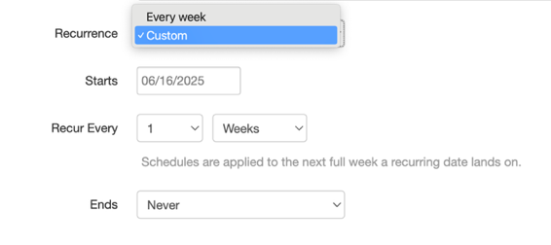
You can use the recurrence option to set your "Days of the Week" time frame to recur weekly or create a custom recurrence. Selecting “Custom” displays the options shown to the right.

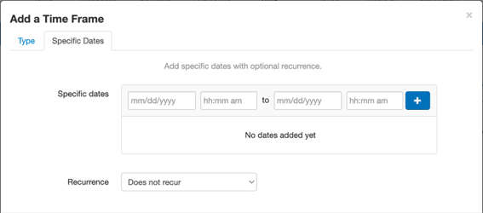
7.1.2 Specific Dates
Name your new time frame and select the “Specific Dates” option. Then click “Next”. This opens the Specific Dates tab shown to the right.

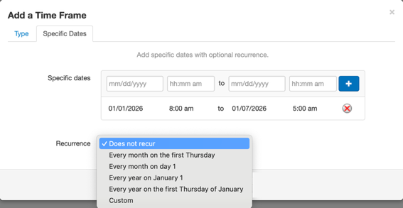
Enter a specific date and time interval during which you'd like your new time frame to be active. The “+” button enables recurrence options for your time frame (shown to the right). Selecting “Custom” provides you with some additional options. See the following examples below.

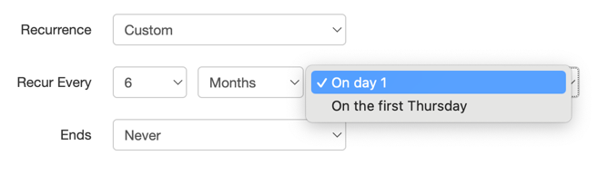
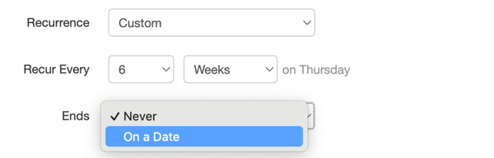

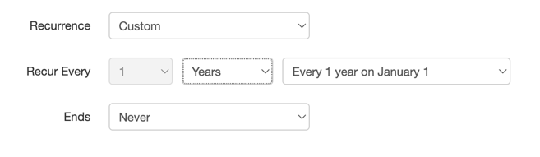

Note: If you add multiple date/time intervals for your new time frame, your recurrence options are limited. See the example above.

7.1.3 Holidays and Observed Holidays
Name your new time frame and select the “Holidays” option. Then click “Next”. This opens the Holidays tab shown below.
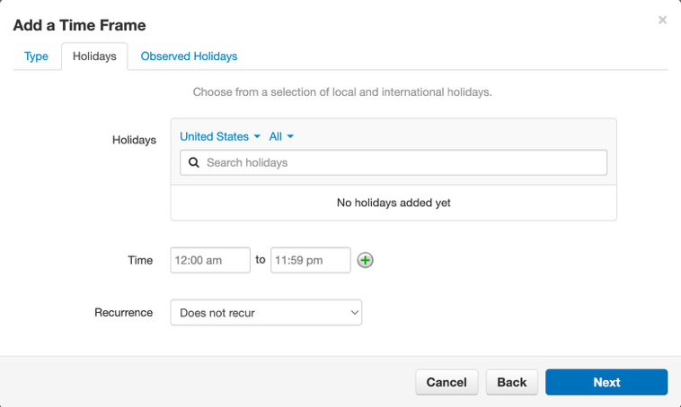

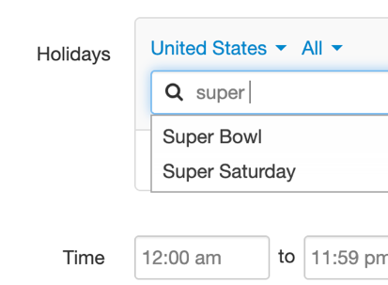
You can search for a holiday by typing it in the “Search Holidays” field as shown on the bottom left. You can also filter the international and local holidays first by using the dropdown arrows shown on the right.
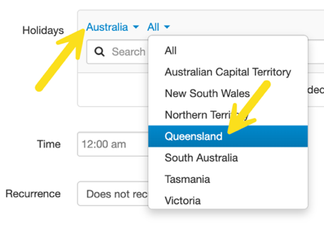

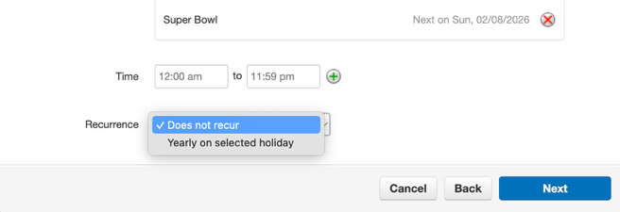
After selecting your desired holiday, edit the time interval if necessary, and choose your recurrence option (shown on the right). Then click “Next” to open the Observed Holidays tab.
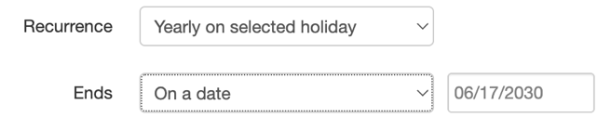
Note: If you choose to have your time frame recur “Yearly on selected holiday”, you will have the option to pick when that recurrence ends.

Use the Observed Holidays tab to set rules for how your company handles holidays that fall on a non-working day, like a Saturday or Sunday. This ensures the holiday can be observed on a weekday if needed. For example, if New Year's Day falls on a Saturday, you can create a rule to observe the holiday on the preceding Friday. If it falls on a Sunday, you can set the rule to observe the holiday on the following Monday.

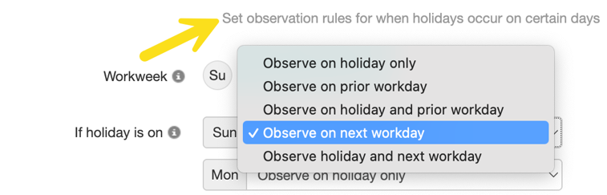
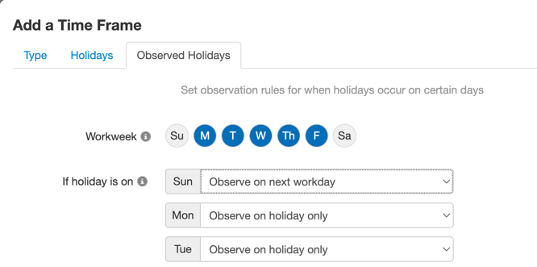

The blue selected workdays represent the typical workweek that should be applied to that time frame. This is needed for determining observed holidays surrounding weekends.

7.1.4 Custom Time Frames
The custom time frame acts as a parent time frame that can then have different types of child time frames within it. Name your new time frame and select the “Custom” option. Then click “Save”. This will open the “Custom Time Frames” page shown below.
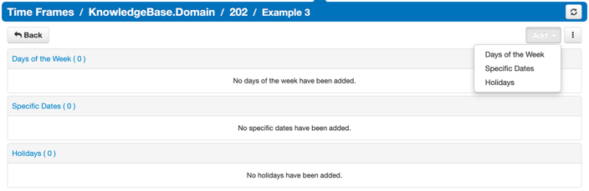

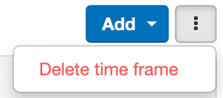

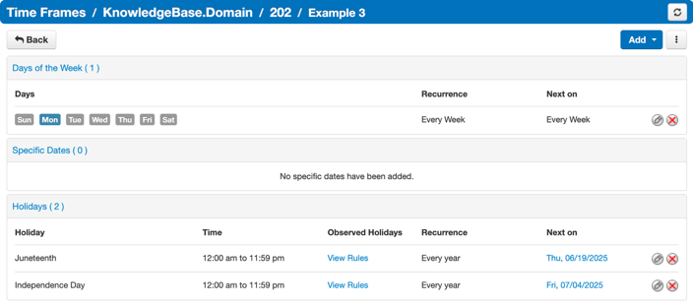
Click the “Add” button. Choose "Days of the Week," "Specific Dates," or "Holidays" to customize your time frame. Each option opens a corresponding modal (see sections 7.1.1, 7.1.2, and 7.1.3).
A running summary displays your selections as you add them. You can also delete the time frame by clicking the button with three dots or by clicking the red “X” in that row.


8 The Phones Page
Click the “Phone” button to open the Phones page shown below.

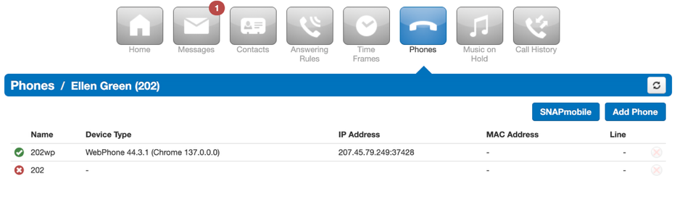
This page lists all registered and unregistered devices on your account. The “green check” icon means that device is registered and fully functional for calls. The red “X” icon indicates an unregistered device. This could be due to a soft phone not being active/open or a hard phone not being on.
The following device information is to the right of the status indicator:
- Name
- Device Type
- Registered IP Address
- MAC Address
- Line number and Extension Number

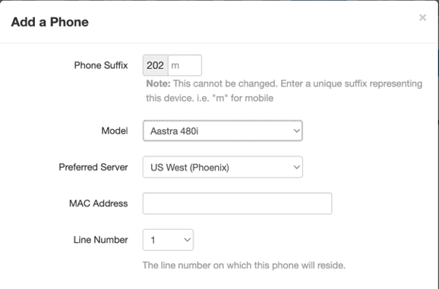
8.1 Add Phone
Click the “Add Phone” button to open the Add a Phone modal as shown on the right.
- Phone Suffix: A short, unique identifier (e.g., "m" for mobile) that helps distinguish this specific device. This cannot be changed after creation.
- Model: The specific model of the device being added. Select from the dropdown list.
- Preferred Server: The server location that this phone will primarily connect to. Choosing a server geographically closer to the phone's location can improve call quality.
Note: However, when possible, all phones within an organization should be assigned to the same server to improve call stability.
- MAC Address: The unique Media Access Control (MAC) address of the phone device. This is a physical identifier usually found on a label on the phone itself.
- Line Number: The specific line (or extension) on which this phone will operate.

8.2 K7 One
Click the “K7 One” button to open the K7 One modal shown below. The modal offers information on downloading the mobile app and the credentials needed to log in. K7 One expands your VoIP capabilities beyond traditional desk phones. It integrates K7 One’s platform features directly onto your mobile device, offering a unified communications experience.
With K7 One, you can make and receive calls from any location while maintaining a consistent identity across all your devices.

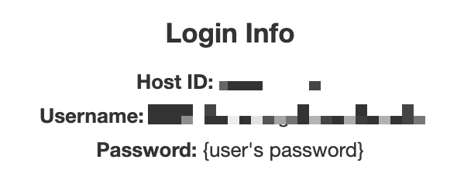
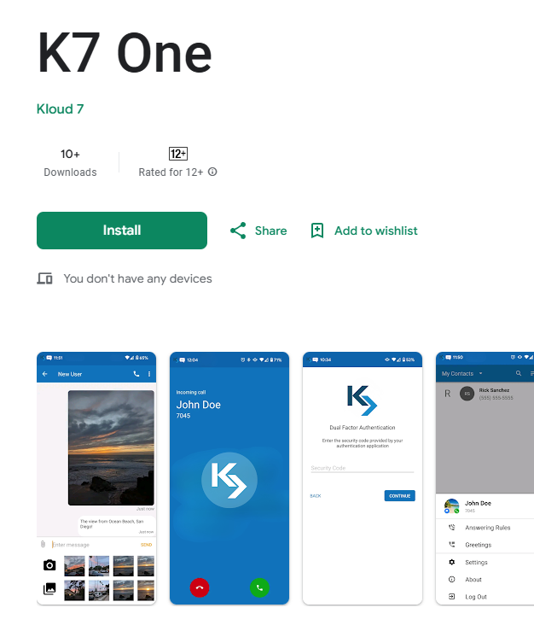

9 The Music on Hold Page
Navigate to the Music on Hold page, shown below, by clicking the “Music on Hold” button. This page can be used to modify music and messages.

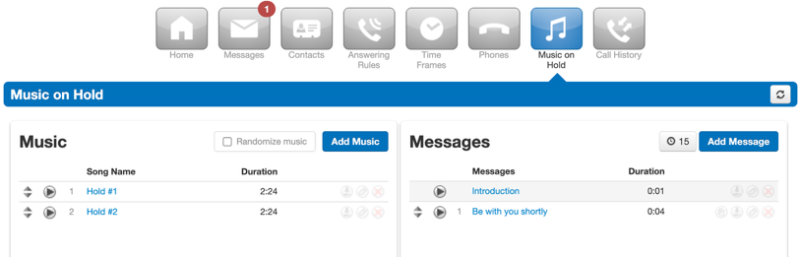
For example, while a customer is on hold, music on hold can be briefly interrupted with a message, such as: "Your call is important to us. Please wait on the line and an agent will be with you shortly." Messages can be used for advertising, updating wait time, and more. Messages are also configurable (time between messages, copying messages, etc.).

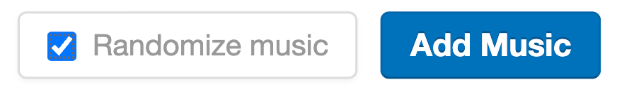 | Randomize the current music list.
 | Browse your computer for MP3 or WAV files.
 | Duplicate message.
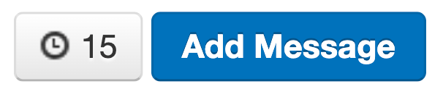 | Set the number of seconds between messages.
 | Opens the Add Message modal (Similar to the Manage Recorded Name modal in section 4.3.2).

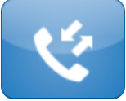
10 The Call History Page
Clicking the “Call History” button opens the Call History page shown below.
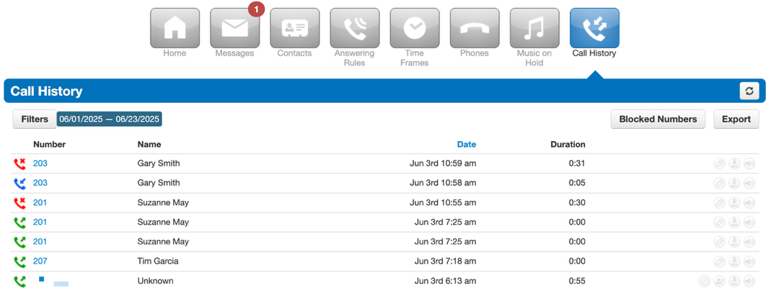

10.1 Filters
Clicking the “Filters” button opens the Call History Filters modal shown below:
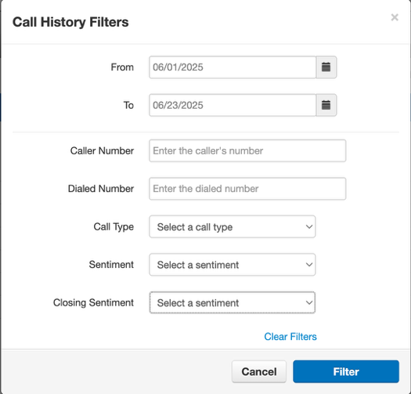
  - From: The start date for the call history you want to view. Calls made on or after this date will be included.
  - To: The end date for the call history you want to view. Calls made on or before this date will be included.
  - Caller Number: Enter a specific phone number to filter for calls originating from that number.
  - Dialed Number: Enter a specific phone number to filter for calls made to that number.
  - Call Type: Select a category of calls to display, such as inbound, outbound, or missed calls.
  - Sentiment: Filter calls based on the detected sentiment (e.g., positive, negative, neutral) during the conversation.
  - Closing Sentiment: Filter calls based on the detected sentiment (e.g., positive, negative, neutral) at the end of the conversation.

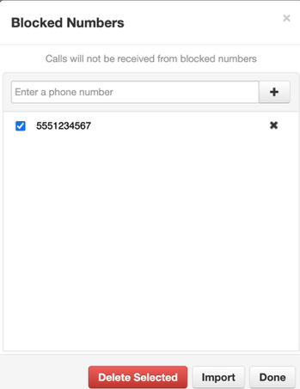
10.2 Blocked Numbers
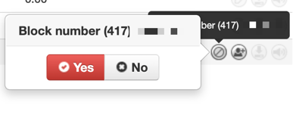
Block unwanted calls by clicking the gray “Block” button next to the duration column and confirming (shown on the left).
A red “Block” button indicates the number is blocked; click it again to unblock.

Clicking on “Blocked Numbers” opens the Blocked Numbers modal to the right. You can block a number by typing it into the “Enter a phone number” field and clicking the “+” button. You can also “Delete Selected” numbers from the blocked numbers list, as well as “Import” numbers to block via a CSV file.

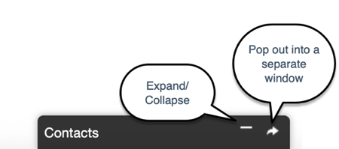
11 The Contacts Dock

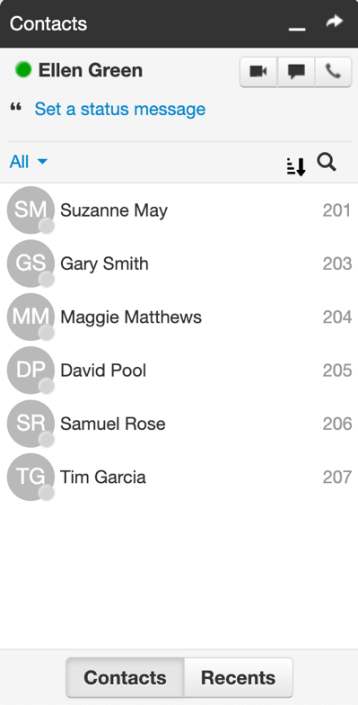
The Contacts Dock appears on the lower right side of your page. Click the “expand” button to open the Contacts Dock shown below.
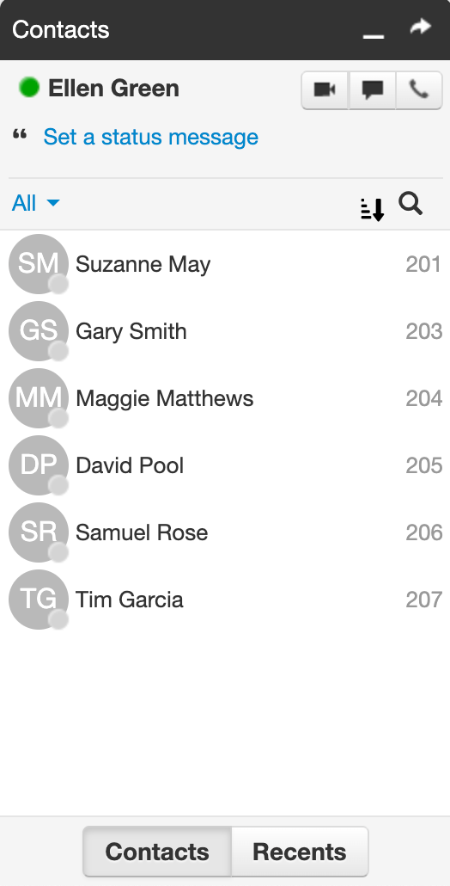 | This shows your name and presence. Ellen is currently online and able to take calls (green).
 | Write a custom status message. This message will be seen in other users’ contacts list.
Access the video conferencing tool. You have two options:
- Start a meeting
- Schedule a meeting
 | Open the Chat/SMS dock where you can type in a name or number and send out a message.
 | Open the “Make a Call” dock.
 | Filter by Contact Groups or Status.
 | Contact Groups:  - All  - Favorites  - Shared  - My Contacts  - Coworkers  - Sites  - Departments | Status:  - Available  - Busy  - Offline
Re-order your contacts list by:

- Online (online first)
- Extension (lowest to highest)
- First Name (alphabetical)
- Last Name (alphabetical)
 | Search your contacts by name or number.
 | Show which contacts you've recently chatted with, including the last message sent.
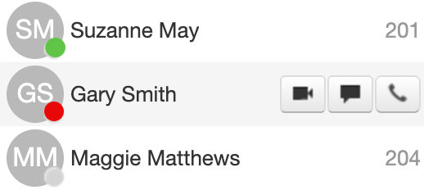 | This is your contact list. Hover over a contact to see the buttons, allowing you to video, message, or call the contact.  The colored circle is the presence icon. The color shows the status of the user:  Green = Available  Red = Busy  Gray = Offline (depending on your version, this will include all non-online statuses)

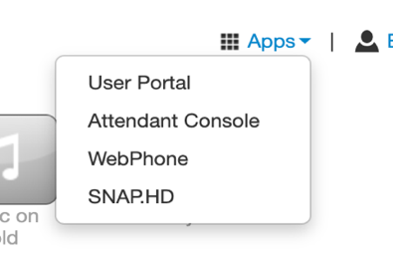
12 Applications
The “Apps” dropdown menu is located at the top right of the User Portal. Click the dropdown menu to reveal access to the following applications: Attendant Console, WebPhone, and K7 One.
Note: Your list of applications may differ depending on your company's customizations.

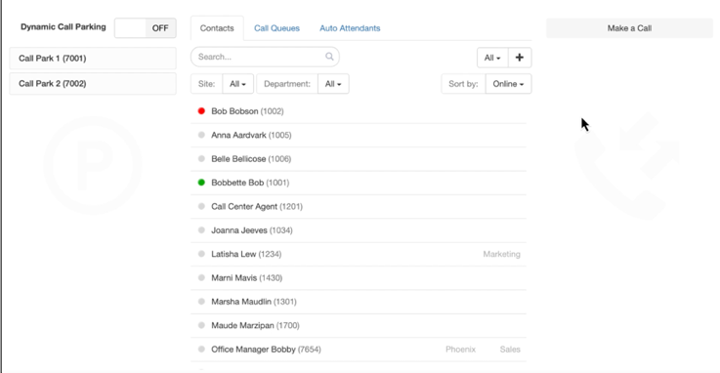
12.1 Attendant Console
The Attendant Console is a comprehensive application designed for efficient call management and real-time visibility within an organization's communication system. Click “Attendant Console” to open a new tab, pictured to the right.
Within this application you can:
- See the live status of all users in your domain, including their availability and active call features.
- Leverage “Click and Drag Call Management” technology. Seamlessly handle calls by dragging and dropping them to perform actions like transferring or call parking.
- Track active call queues with real-time visibility into caller wait times and agent status.
- Transfer calls directly to your organization's configured Auto Attendants for automated routing.

12.2 WebPhone
WebPhone offers a convenient way to manage your communications directly from your web browser. Click the “WebPhone” application to open a new tab, shown below.
Within this application, you can:
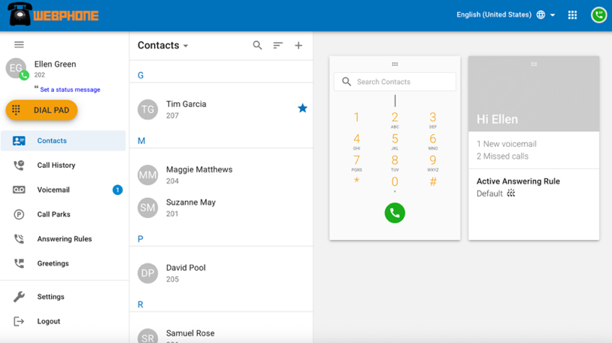
- Make and Receive Calls: Use the integrated dial pad or your contacts to easily initiate and answer calls.
- Manage Contacts: Access, search, and organize your contact list for quick dialing.
- Review Call History: View a detailed log of your incoming, outgoing, and missed calls.
- Access Voicemail: Listen to, manage, and retrieve your voicemail messages.
- Manage Call Parks: Handle parked calls, allowing you to temporarily hold calls and retrieve them later.
- Set Answering Rules: Customize how incoming calls are handled based on your preferences.
- Set Greetings: Manage your personalized voicemail greetings.
- Adjust Settings: Control various app settings, including audio devices and notification preferences.
- Set Status Message: Inform others of your availability or current activity

Kloud 7 Business Communications - hello@kloud7.com - (844) 855-6837

