Voicemail Manual

Voicemail is a fundamental telecommunications feature. This article explains how to access voicemail boxes depending on the means of communication, how to configure voicemail beyond the system defaults, and explains the voicemail IVR tree.

Checking Voicemails
There are many methods for checking voicemail messages.
Refer to the following table based on preferred means of communication:

Means of Communication | How to Check Voicemails
Hard Phone - Button | VoIPdesk phones have a pre-configured voicemail button. The location of this button is dependent on the model and brand.  - Look for a voicemail icon button near the dial pad:    - Or a message icon button near the dial pad:    - Or the "Messages" option in the Main Menu:    Any of these actions will connect you straight to that device's voicemail box. Then enter the pin to access messages.
Hard Phone - On-Net Dialing | The voicemail box can also be accessed by dialing an extension. By default, x5001 connects users to their voicemail box and x5000 allows users to check a different voicemail box. Voicemail pins are still required to access messages.
Hard Phone - Off-Net Dialing | Read "How Can I Check Voicemail Messages Remotely?" to access a voicemail box from an off-net number. Once configured, the user can check voicemail messages by calling their direct phone number and pressing the # or * key (depending on what was configured) once the voicemail greeting starts playing.
User Portal | Navigate to the User Portal > Messages.  Options here are to play a voicemail, call to play, forward, download, or delete.  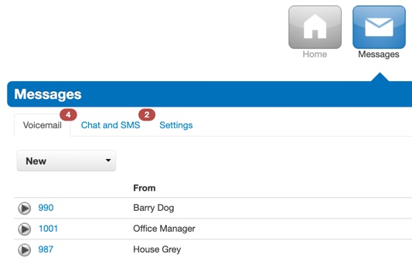
K7 One mobile iOS / Android | Navigate to the K7 One mobile app > Voicemail tab.  Options in both iOS and Android are playback, return the call, save the voicemail, forward, move to trash, and more options (adding as a contact, sending an SMS, etc.).  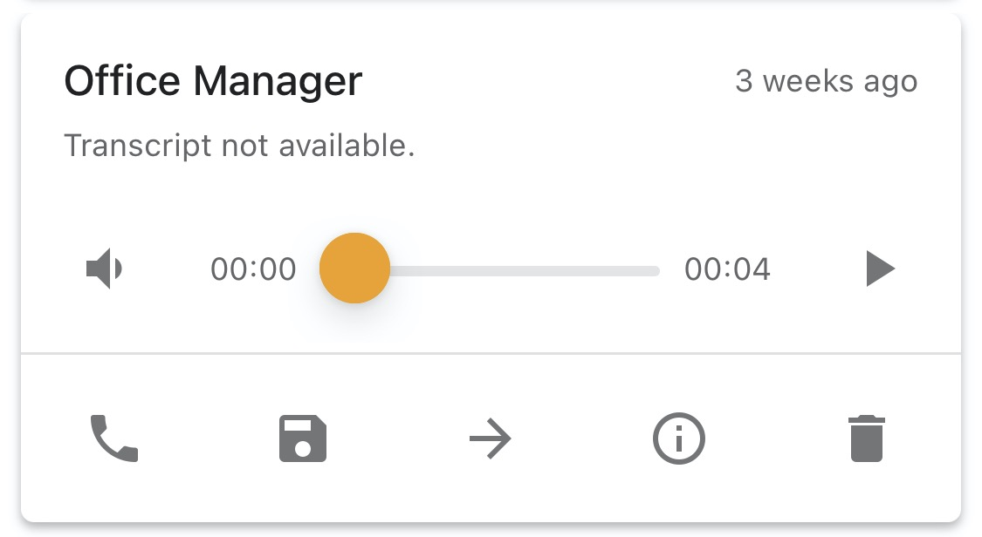
K7 One mobile Web | Navigate to the User Portal > "Apps" dropdown > Portal Web Phone.  Voicemail options are playback, save, forward, and delete.  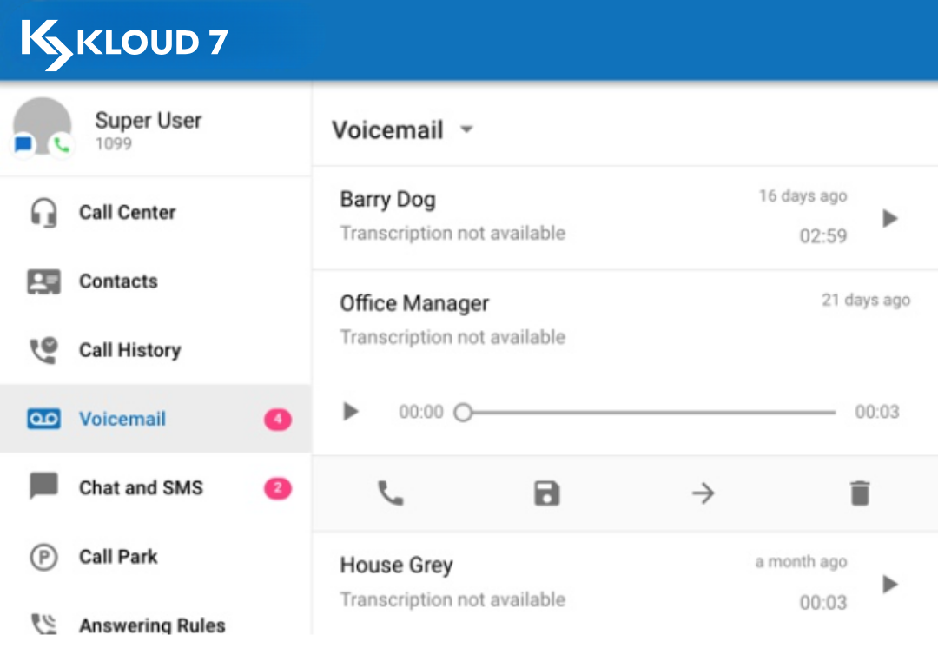

Voicemail Greetings & Recorded Names
- Navigate to the Portal > My Account (if scope is Office Manager or above) > Messages > Settings.
- Across from Greetings, existing greetings and names can be played or downloaded.
- If the only button you see is a "manage" button (a megaphone icon), then that means there are no Voicemail Greetings or Recorded Names configured for this user.


Add a Voicemail Greeting
Use the "manage" button (a megaphone icon) across from "Voicemail Greeting" to manage existing greetings and add new ones.
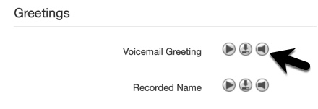
There are 3 options for adding a new greeting: (1) use text-to-speech to transform your typed words into computer-generated audio, (2) upload an existing MP3 or WAV file, or (3) call a number to record your greeting in real-time.
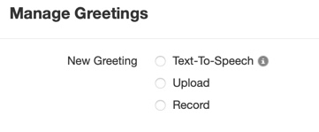
Text to speech | 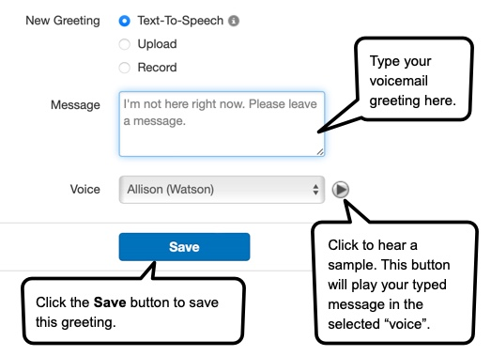
Upload | 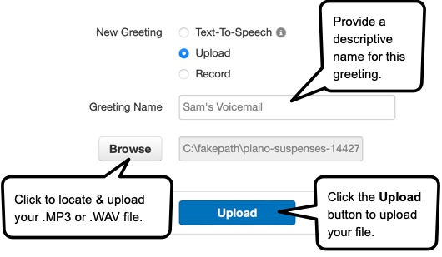
Record | After selecting the "Record" option and then naming the greeting, decide where you want to be called. The system will call you at this number and ask you to record your greeting.  For on-net numbers (extensions), you must specify the device. For example, the user in this example is asking to be called at their WebPhone.    For off-net numbers (DIDs), you may be required to use the country code. Here's a U.S. example:    - Press the Call button.  - The system will call you at the number you entered.  - Answer the call.  - It will prompt you to record your greeting: "Start recording after the tone. Press pound when finished".  - After pressing # (pound), you can hang up.  - Then your recorded greeting will automatically be added to the refreshed table ("Ellen's Voicemail" in this example).  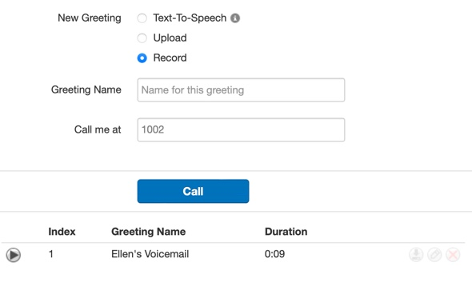

Delete a Voicemail Greeting
Voicemail Greetings can be downloaded, edited, or deleted by clicking on the respective button across from that greeting. They can also be sampled by clicking on the play button (to the left of the greeting).
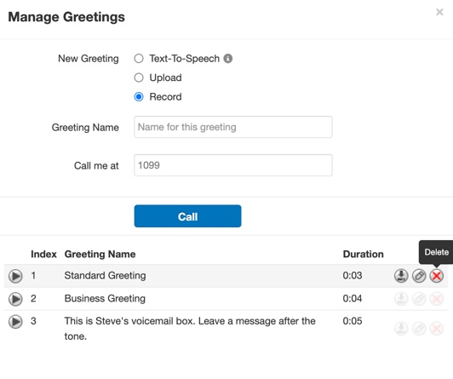

Create a Recorded Name
- Use the "manage" button (a megaphone icon) across from "Recorded Name" to replace the existing name.
- If the "manage" button is the only button across from "Recorded Name", that means this user has not created their name yet.
- There are 3 options for adding a new name: (1) use text-to-speech to transform your typed words into computer-generated audio, (2) upload an existing MP3 or .WAV file, or (3) call a number to record your name in real-time. These are the same options that exist for adding a Voicemail Greeting. Refer to the above table for details. Note that the only difference is that only one Recorded Name can be stored, whereas multiple Voicemail Greetings can be stored. Adding a new Recorded Name will replace the existing file (if one exists).

Disable Voicemail Call Forwarding
"Securing your K7 One System" explains how to disable voicemail call forwarding. This security precaution is a recommended best practice to prevent call fraud.

Voicemail Limits
"Can I Set A Minimum Length For The Voicemail PIN That Clients Use?" is a useful article for enhancing voicemail security.
"How Can I Limit The Length Of A Voice Mail Recording?" explains how to set the "max v-mail" timer.
"How Do I Route Calls to Voicemail When a User's Call Limit is Reached?"

Voicemail Notifications
"Configure Email Notification for New Users' Voicemail"
Read about email notifications at the user level in the "Scheduled Export" section of "Call History Page & CDR2 Overview".
"Voicemail Reminders" was a feature introduced in v43.0. This is how to set up persistent notifications via email, phone, and/or SMS.
"Branding Notification Emails" includes a section on "Email Templates" and explains how to brand automatic emails when users have missed a call or received a voicemail message.
"Is It Possible To Copy A Voicemail To Another User And Keep My Copy?" explains how to automatically send a voicemail copy to a different mailbox than where the message was left.

Voicemail IVR Tree
IVR (Interactive Voice Response) is a computer technology that translates voice and dial tones into commands to route users to the correct place. For example, "press 1 to record a greeting" uses IVR technology. The user presses "1" on their phone, and the underlying technology understands the specific button tone, translating it into the appropriate action - letting the user record a greeting. More information about the types of menus can be found here, "Voicemail Menus".

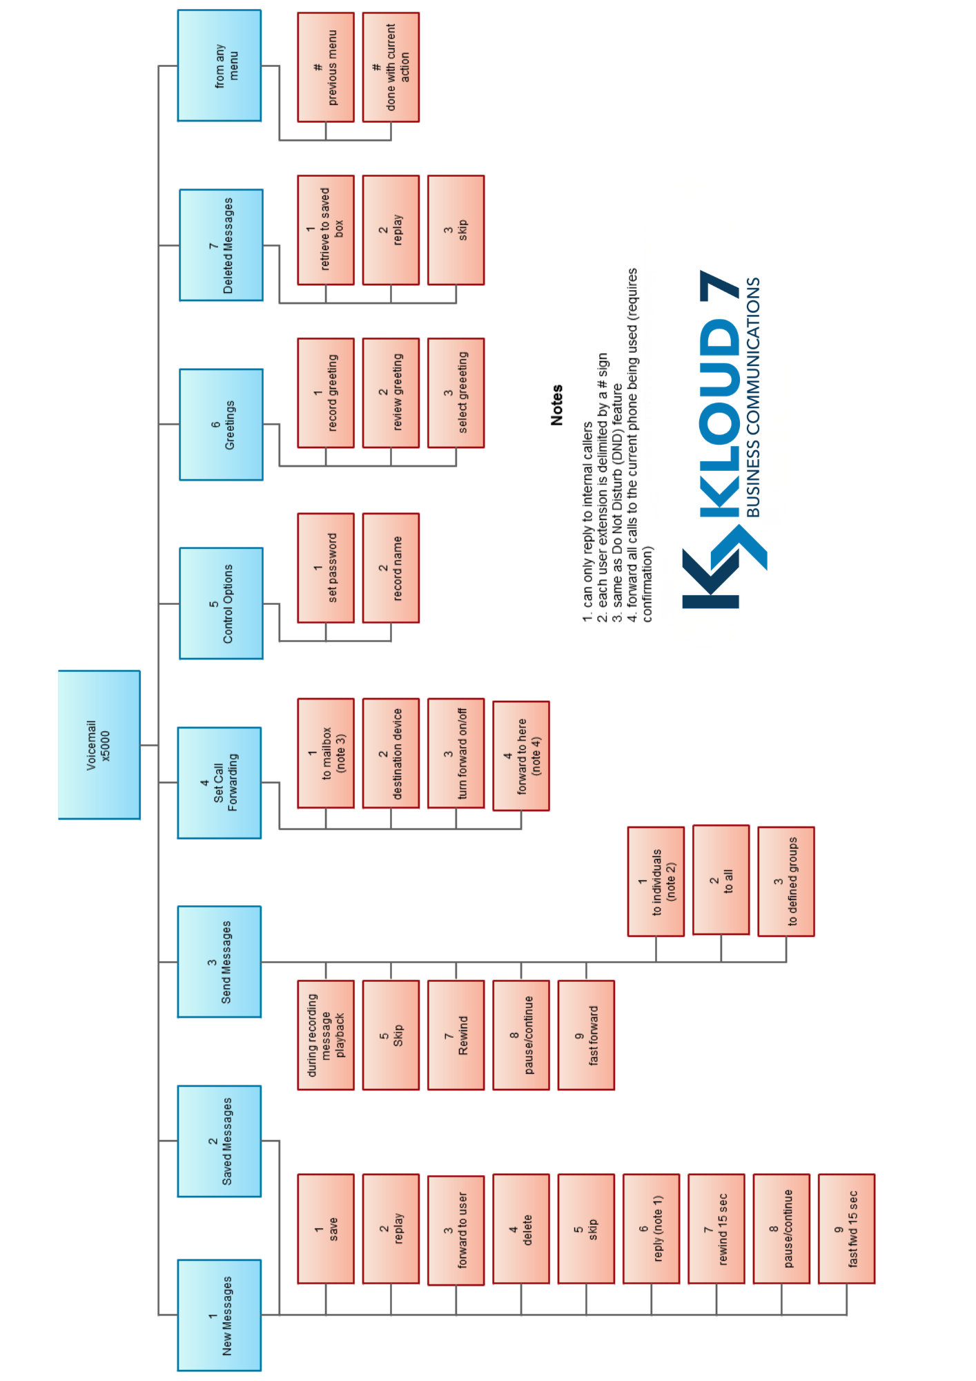
The following IVR tree is what K7 One uses inside voicemail boxes:

Kloud 7 Business Communications - hello@kloud7.com - (844) 855-6837

