Purpose.
This document gives step by step instructions on how to have the web application working.

Step 1.
Login to your K7 one portal. On https://portal.kloud7.net/
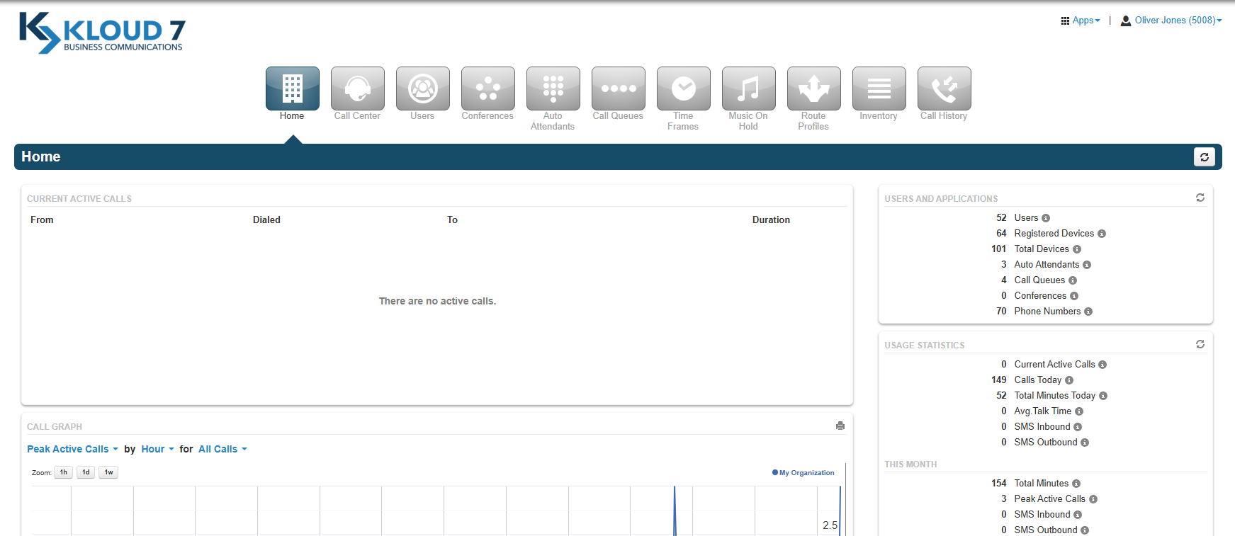

Step 2.
Hover over the application button on the top right corner
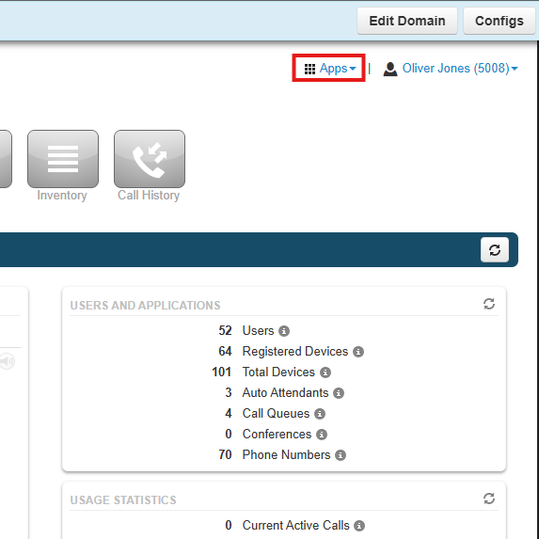

Step 3.
Click on the K7 One - Web Phone.
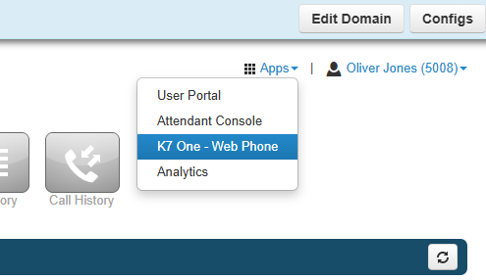

Step 4.
This will move you towards a new tab with our K7 One - Web Phone
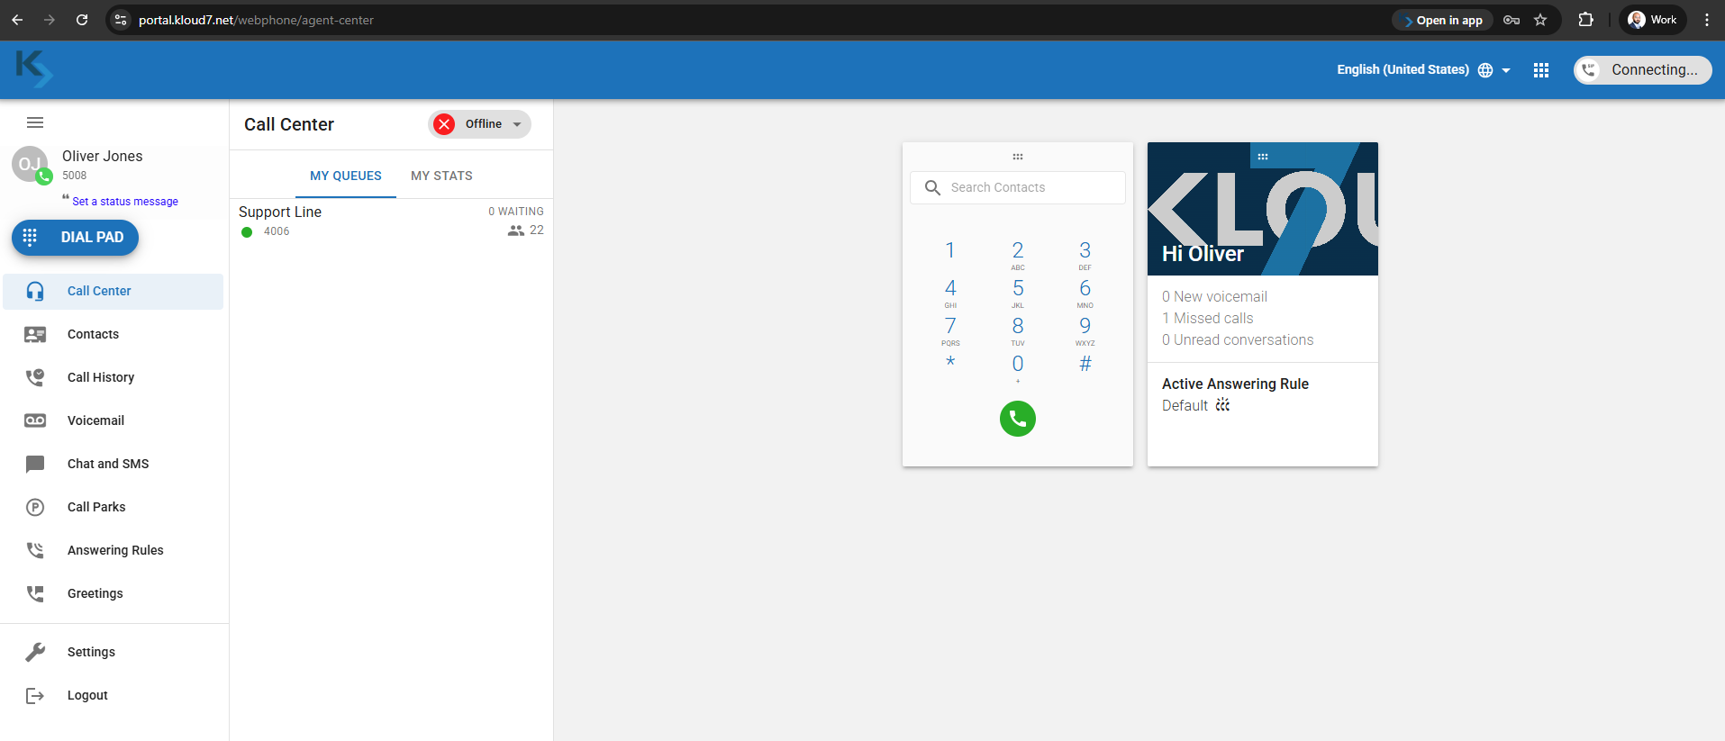

Step 5.
Click on “Install” to have a separate window and an Icon on your desktop whenever you’d want to access the application in the future.

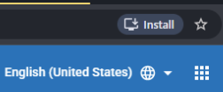

Click on Install
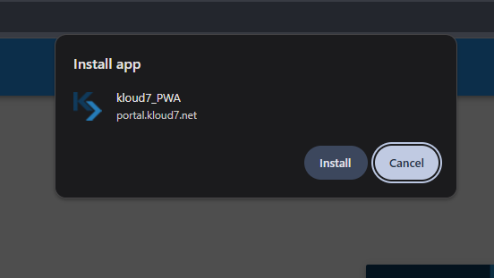
You successfully have your web application installed on your PC as a standalone app.
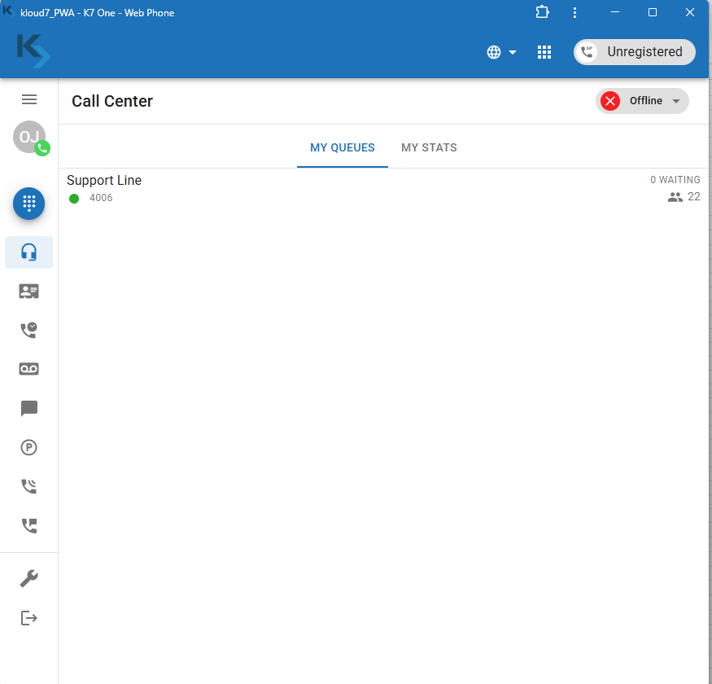

An Icon will automatically be created on your desktop to access the application.

